BID3000 Final Report

Business Intelligence and Data Warehouse
Group Exam – Autumn 2025

Universitetet i Sørøst-Norge

Name | Candidate Number | Student Number
Sarina Chui Ling Ng | 7013 | 26609
Khalil Ahmad Jabbar | 7023 | 265927

Contents
BID3000 Final Report 1
1. Warehouse Design Decisions 5
1.1 Star schema architectural overview 5
1.2 Our implementations (ERD) 5
1.3 Description of primary keys, foreign keys and indexing strategies 8
1.3.1 The primary keys for each dimension table 8
1.3.2 The primary keys for each fact table 8
1.3.3 Foreign keys for fact tables 8
1.3.4 Indexing Strategies 9
1.4 Design rationale and grain definition 13
1.4.1 Fact table 1: fact_order_lines 13
1.4.2 Fact table 2: fact_delivery 13
1.4.3 Fact table 3: fact_payment 14
1.4.4 Fact table 4: fact_review 14
2. ETL process 15
2.1 dim_time table transformation 15
2.2 dim_category table transformation 15
2.3 dim_review_comments table transformation 16
2.4 dim_location table transformation 16
2.5 dim_seller table transformation 16
2.6 dim_customer tabel transformation 17
2.7 dim_product table transformation 17
2.8 fact_order_lines table transformation 18
2.9 fact_payment table transformation 18
2.10 fact_delivery table transformation 18
2.11 fact_review table transformation 19
3. Data quality issues identified and resolution strategies 19
4. Performance considerations and optimization techniques applied 20
4.1 Database performance optimizations with index strategy 20
4.2 Constraints implementation 20
4.3 ETL Performance Optimization (Pentaho) 21
5. SQL Analytical Queries - Query results and analytical outputs 22
6. Python Analytics Integration - Business interpretation of findings 24
6.1 Descriptive analysis – on time delivery analysis 24
6.2 Descriptive analysis – regional sales analysis 25
6.3 Predictive analysis – customer churn analysis 25
6.4 Predictive analysis - Price Elasticity Analysis 25
6.5 Prescriptive analysis - Freight Cost Optimization 25
6.6 Prescriptive analysis: Customer Segmentation Strategy 25
6.7 Prescriptive Model: Delivery Performance Optimization 26
7. Documentation of DAX calculations and design decisions 26
7.1 Dax calculations 26
7.2 Design decisions 31
8. Reference 35
9. APPENDIX 36
APPENDIX A 36
APPENDIX B 36
APPENDIX C 37
APPENDIX D 37
APPENDIX E 38
APPENDIX F 38
APPENDIX G 39

Warehouse Design Decisions

1.1 Star schema architectural overview
With a star schema, fact tables are in the center with the dimensional tables around, so it looks like a star (Sharda, Delen, & Turban, 2024). We have Kimball-style star schema, it is standard for an analytical standpoint in the industry (Kimball & Ross, 2013). Fact tables contain quantitative data about business events and transactions. Each row represents a business event in a specific grain. The foreign keys link to dimension tables. Dimension tables provide who, what and where? They can contain categorical and textual attributes used for grouping and filtering.

1.2 Our implementations (ERD)
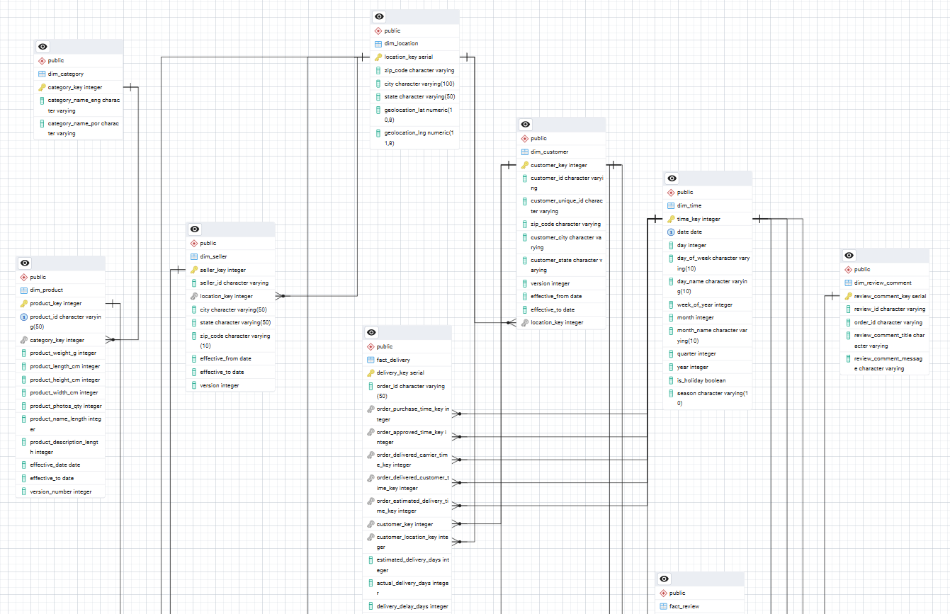
The full ERD file is located in the Documentation and Screenshots folder.
We have four fact tables that represent different business processes and are fit with the task and to the brazilian e-commerce dataset by kaggle. (Data source: https://www.kaggle.com/datasets/olistbr/brazilian-ecommerce)
Fact_order_lines = Sales transactions
- Individual product sales at line-item level. It contains freight_value, price and quantity.
- Links up to product, customer, seller, time and location.
- Relevant for total revenue, detailed sales metrics and ect.

Fact_delivery = Delivery logistics
- Tracks and evaluates logistics and fulfillment performance with delivery dates.
- Links up to customer, seller, time and location dimensions.
- Since it has transit time and on time metrics, it enables delivery performance analysis and customer satisfaction measurement.

Fact_payment = Payment processing
- Tracks payment transactions details including payment value, installment and payment type.
- Links up to customer and time dimension.
- Supports payment method analysis.

Fact_review = Customers reviews
- Customer reviews (1-5 stars). Links to product, customer, and time dimension.
- It is used for quality assessment and customer satisfaction analysis.

These fact tables are connected with 6-dimension tables that also fit with the dataset from kaggle.
dim_product = what product was sold?
- Contains product name, physical dimensions (weight, height, width and length), photo counts, description length and category reference.

dim_category = what type of product is it?
- Product categorization with category names in both Portuguese and English for reporting support.

dim_customer = who bought it?
- Customer master with historical tracking. Contains customer Ids, unique identifier, location reference and validity dates (effective_from, effective_to) for tracking customer changes over time.

dim_seller = who sold it?
- Seller information includes seller ID, location reference, and validity dates for historical seller tracking.

dim_location = where did the sale happen?
- Brazilian geographic hierarchy containing zip code, state, city and coordinates (latitude, longitude) for spatial analysis.

dim_time = when did it happen?
- Important calendar dimension with date components, year, month day of week and week.
dim_review_comment
- Collect all reviews that have a comment title or comment message
- Enable detailed analysis of reviews

This gives an overview of how a star schema works. Single hops in queries from fact to dim make them simple. Since it is denormalized we get fast performance.

1.3 Description of primary keys, foreign keys and indexing strategies

1.3.1 The primary keys for each dimension table
dim_category: category_key (integer) – Auto-incrementing surrogate key
dim_customer: customer_key (integer) – Auto-incrementing surrogate key, with natural key customer ID from source
dim_location: location_key (integer) – surrogate key for geographic data
dim_product: product_key (integer) – surrogate key, with natural key product id from source
dim_seller: seller_key (integer) – surrogate key,with natural key seller id from source
dim_time: time_key (integer) – surrogate key
dim_review_comment: review_comment_key (integer) – surrogate key, with natural key which is a combination of review_id and order_id

1.3.2 The primary keys for each fact table
Fact_order_lines: order_line_key (integer) – surrogate key , with natural key which is a combination of order_item_id and order_id
Fact_payment: payment_key (integer) – surrogate key, with a natural key which is a combination of order_id and payment sequential
Fact_review: review_key (integer) – surrogate key, with a natural key which is a combination of review_id and order_id
Fact_delivery: delivery_key (integer) – surrogate key, with a natural key order_id from source

1.3.3 Foreign keys for fact tables
Fact_order_lines links to
- Dim_product (product_key)
- Dim_seller (seller_key)
- Dim_time (time_key)
- Dim_location (location_key)

Fact_delivery links to
- Dim_customer (customer_key)
- Dim_seller (seller_key)
- Dim_time(time_key)
- Dim_location (location_key)

Fact_payemnt link to
- Dim_customer (customer_key)
- Dim_time (time_key)

Fact_review links to
- Dim_product (product_key)
- Dim_customer (customer_key)
- dim_time (time_key)

Dimension foreign keys
Dim_seller – dim_locaiton (location_key)
Dim_customer – dim_location (location_key)
Dim_product – dim_category (category_key)

1.3.4 Indexing Strategies
Our indexing strategy optimize analytical query performance by placing indexes on frequently filtered columns, all foreign keys, and attributes used in common query patterns.

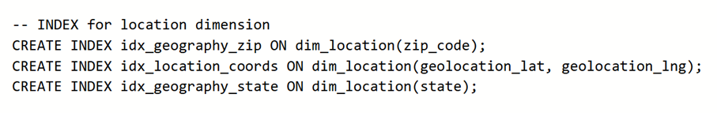
- Zip code index support location lookups
- Coordinates enable geographical radius searches
- State index facilitates regional aggregations.

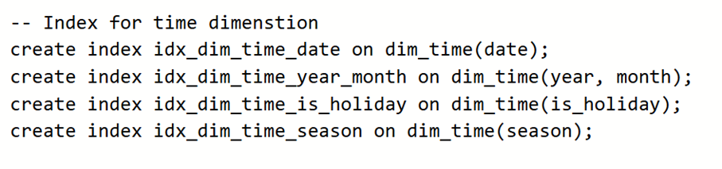
- Date index supports direct date filtering.
- Year-month index monthly and quarterly aggregations
- Holiday indexes enable us to analyze patterns vs non holiday
- Season indexes enable us to analyze patterns through seasons

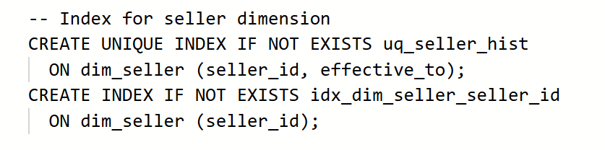
- Seller_id index supports natural key lookups and source system joins.
- SCD Type 2 integrity is forced for unique historical analysis

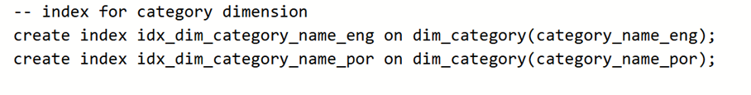
- Index support categorical filtering in both English and Portuguese
- Easier for international BI reports

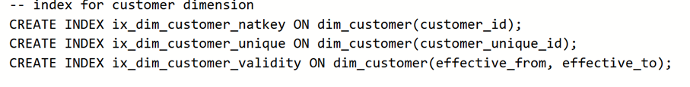
- Unique id index support customer deduplication ‘
- Natural key index enables source system reconciliation

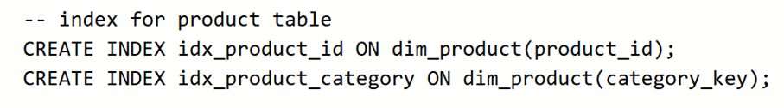
- Natural key lookups and source system reconciliation
- Optimizes product-to-category joins and category level filtering.

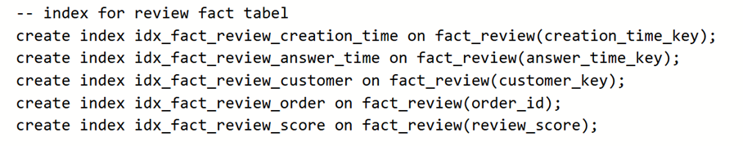
- Index support time-bases analysis, when reviews were created and answered
- Customer index enables customer review history queries
- Order_id index links reviews to transaction
- Score index optimizes filtering by rating

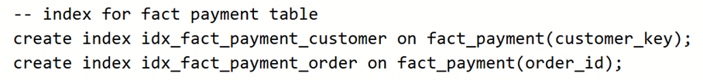
- Customer index enables customer payment pattern analysis and payment history queries.
- Order_id index links payments to orders for financial reconciliation and supports queries joining payment data with other order-related facts.

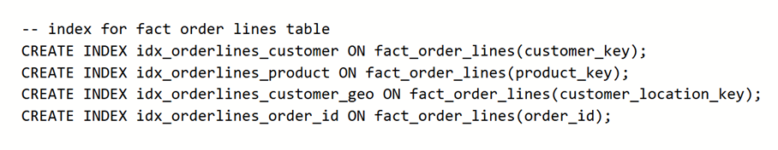
- Product and customer indexes optimize most common joins to dimension tables
- Geographical indexes support regional analysis
- Order_id index enables order-based queries and joins to other fact tables (payment, delivery, review)

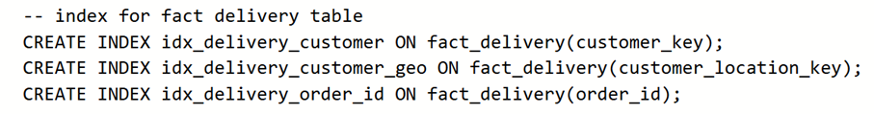
- Customer index optimizes customer delivery history queries
- Geographical index supports regional delivery performance analysis
- Order_id index links deliveries to orders and enables joins with other fact tables for order-to-delivery analysis.

1.4 Design rationale and grain definition

1.4.1 Fact table 1: fact_order_lines
The grain definition is one row per individual product within an order.
Each row represents one product type purchased in one specific order, if a customer orders three different products in one order, it will mean three rows in the table. Moreover, if a customer orders 2 units of a product, it will be one row, but two in quantity.
The grain is chosen with Kimball mythology; we store data at the lowest level possible. We can also aggregate levels as we like. This makes sure that we have flexibility in the fact table. We can also analyze data in detail, for example the revenue based on items and geography, which items sell more than one unit in average order. The possibilities are many for analyzing, which makes this grain great.
We can furthermore calculate and count, which is essential for data analysis.
- Quantity - units of product sold
- Price - unit price for product
- Freight_value - shipping cost

1.4.2 Fact table 2: fact_delivery
The grain definition is one row per delivary process for each complete order
Every order gets one record of delivery; it will track the entire road from confirmed to delivery.
This grain is very important, as we can aim for the goal of optimizing the logistics. With data we can see if the customers are getting their deliveries on time or not. This grain is totally different from sales; it is meant for logistics. We can analyze from both seller and geographical standpoint, who is fastest and slowest? How many deliveries are due? The possibilities for analyzing are many.
- Estimated_delivary_days – Estimation for delivery days
- Actual_delivary_days – The actual delivery days
- Delivery_delay_days – Delays for the delivery days
- Total_freight_value – Total shipping cost for entire order

1.4.3 Fact table 3: fact_payment
The grain definition is one row per payment transaction
Each row represents a payment transaction. In Brazilian e-commerce, one order can have multiple payment methods. This means one order can generate multiple rows in the fact table.
The grain is essential because payment patterns in Brazil are unique – installment payments are very common. With the grain we can analyze payment behavior in detail. Which payment methods are preferred? How many installments do customers usually make? The possibilities are many.
- Payment_value – Amount paid in transaction
- Payment_installments – Number of installments for this payment
- Payment_sequential – The sequence number if multiple payments exist for one order
- Payment_type – Method used, (credit card. Debit card, voucher, boleto)

1.4.4 Fact table 4: fact_review
The grain definition is one row per customer review of a product.
Each row represents one review written by one customer about one product. Reviews are optional, meaning not every purchase generates a review. One can accumulate many reviews over time from different customers.
This grain is important for quality control and customer satisfaction analysis. With this data we can identify problematic products, understand what customers appreciate, and see how delivery performance affects customer satisfaction. We can analyze review patterns. Which products get the best ratings? Do delivery days correlate with poor reviews? The possibilities are many.
- Review_Score – Customer rating 1-5
- Review_count – Can be counted to see total reviews per product
- Avarage_review_score – Can be calculated per product, category or seller
- Review_response_time – Time between review creation and seller response

ETL process
We use Pentaho Data Integration (PDI) to build ETL transformations. We have created a separate transformation for each table in our database, resulting in a total of 11 transformations. Below, we will show screenshots of each transformation, along with step by step explanations.

dim_time table transformation
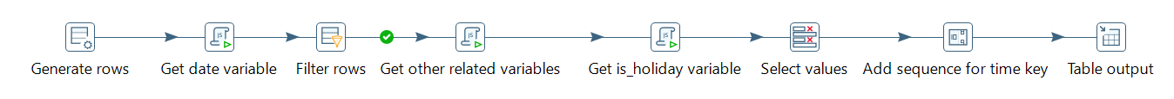
This is the transformation for the dim_time table. It begins by generating a row for the date field, then uses JavaScript to create date variables for the period from 2016-01-01 to 2020-12-31, effectively generating all the required date records. Next, we filter out any rows with null values, and use JavaScript to derive additional variables such as month, year, is_holiday, and others. After that, we use the “Select values” step to choose the final set of columns needed in the database. Finally, we create surrogate key by adding a sequence and write the data into the database.

dim_category table transformation
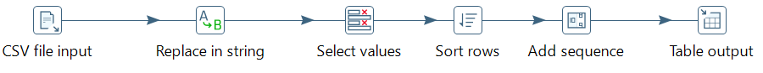
This is the transformation for the dim_category table. It begins by reading data from a CSV file as the source. Next, as part of the data cleansing process, we select UTF-8 as the file encoding to ensure that non-English and special characters are read correctly. We also use the “Replace in String” step to replace underscores with spaces and normalize the text fields. Finally, we select the required columns for the database, sort the rows, add a sequenced surrogate key, and write the data into the database.

dim_review_comments table transformation
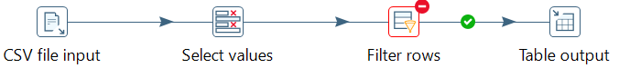
It begins by reading data from a CSV file as the source. UTF-8 is selected as the file encoding method to ensure data quality. Next, it selects the columns needed for the database, filters out rows that do not have review comments, and finally writes the data into the database.

dim_location table transformation
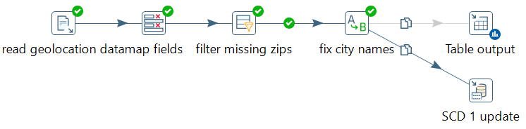
This transformation is quite similar to the previous one in terms of extracting data and selecting columns. However, it filters out rows where the zip code is null and normalizes the data by handling special characters before writing to the table output. SCD Type 1 is implemented in this transformation. We perform a lookup on the ZIP code and update the corresponding state, city, and latitude values accordingly.
During the initial data load, we use the Table Output step for efficiency. Afterwards, if there are any changes in the dataset, we can disable the Table Output step and use the SCD Type 1 step to update the existing records.

dim_seller table transformation
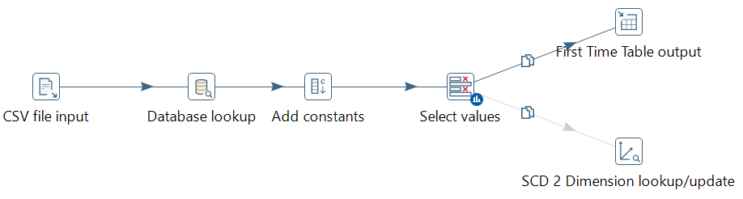
This transformation starts by reading data from a CSV file as the source. Next, it performs a database lookup to retrieve the location_key based on the zip code. We then add constants such as effective_from, effective_to, and version to support SCD updates. After that, the final columns are selected, and the data is written to the target table. To enable SCD Type 2, we implement an SCD 2 dimension lookup. In this lookup, the process searches for rows with the same seller_id and creates a new row with updated information, such as zip code, location key, and other relevant fields. The previous row remains in the table but is deactivated by updating the effective_to date.
The “First Time Table Output” and “SCD 2 Dimension Lookup” steps conflict with each other when used simultaneously in the same transformation. Therefore, we use “First Time Table Output” to load the data initially, delete the step, and then apply the “SCD 2 Dimension Lookup” step for subsequent updates.

dim_customer tabel transformation
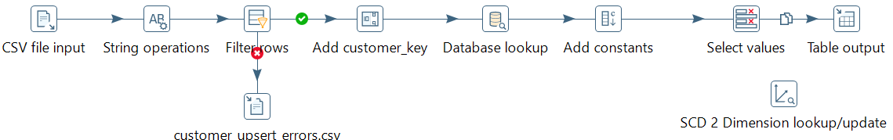
This transformation is very similar to the previous one. However, it includes a “String Operation” step to normalize the data by trimming values and unifying the case format to ensure data quality. It also handles missing data by filtering out rows that do not have customer_unique_id, city, or post_code. In addition, it implements error handling by sending rows with empty data to a separate CSV file. SCD Type 2 is also implemented in this transformation.

dim_product table transformation
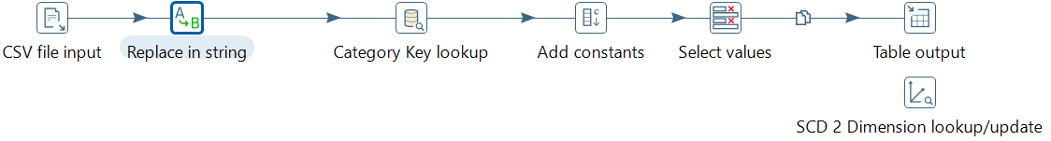
This transformation is very similar to the previous one. In addition, it includes UTF-8 as file encoding method and a “Replace in String” step to replace underscores with spaces, supporting data cleansing. It also performs a category key lookup by comparing category names. SCD Type 2 is implemented in this transformation.

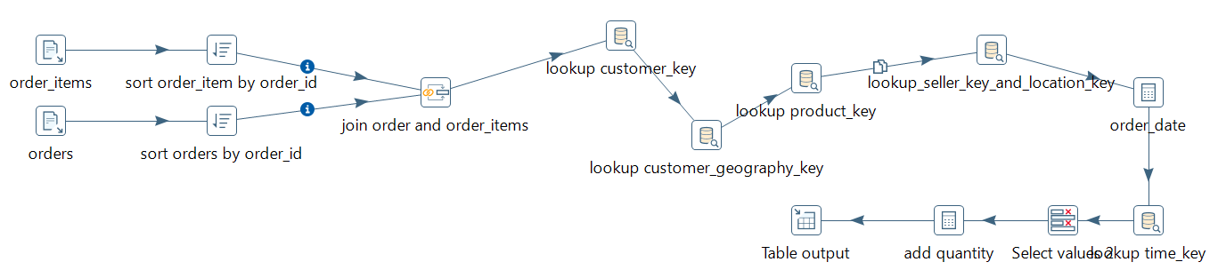
fact_order_lines table transformation
This transformation starts by extracting data from two CSV files. It then sorts the data by order_id and joins the two tables together. Next, it performs lookups for customer_key, location_key, seller_key, time_key, and other relevant fields. It also adds quantity to the order before writing the data to the target table.

fact_payment table transformation
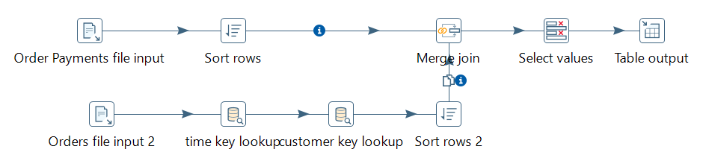
This transformation is similar to the previous one. It extracts data from two CSV files, sorts them, and joins the tables together. It then selects the columns to be included and writes the data to the target table.

fact_delivery table transformation

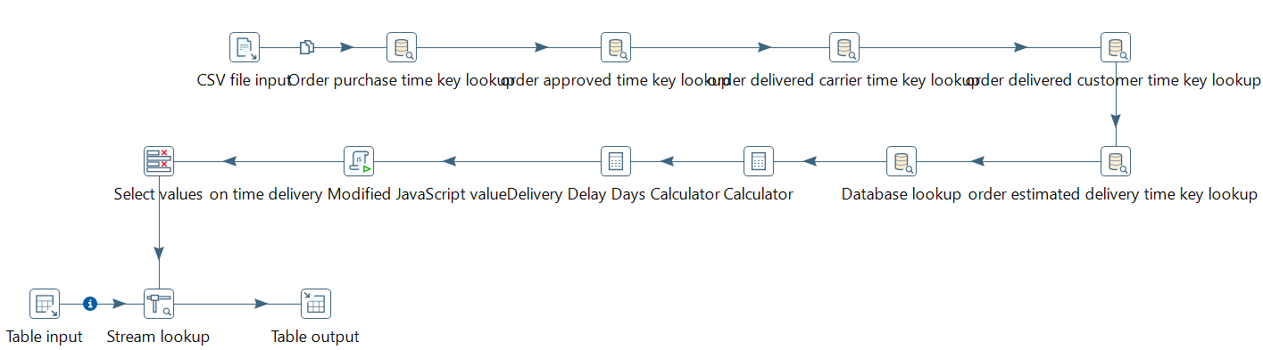
This transformation starts by extracting data from a CSV file. It performs multiple lookups for different time_key values and calculates delivery delay days by comparing the actual delivery date with the estimated delivery date. The data is then enriched by looking up the freight value in the database using the order_id, and finally, the data is written to the target table.

fact_review table transformation
This transformation starts by extracting data from a CSV file. It then performs lookups for time_key, customer_key, and comment_key. Finally, it selects the columns to be included and writes the data to the database.

Data quality issues identified and resolution strategies
During the ETL process, we identified and addressed several data quality issues. The first issue was inconsistent formatting, particularly in the category and location fields. This was mainly caused by the presence of special characters and non-English characters. To resolve this, we set the encoding format to UTF-8 to ensure all data is loaded correctly. Additionally, we applied string operations to further enhance data quality, for example, normalizing text to uppercase/lowercase, removing underscores, and trimming unnecessary spaces.
Another issue we encountered was null values. Rows missing critical fields such as customer_unique_id or zip_code were filtered out and exported to a separate CSV file containing error records. Null values were also handled based on the context of each table. For example, in the dim_review_comment table, we only included reviews that contained actual comments. Therefore, we filtered out any reviews with empty comment titles or comment fields to maintain data quality.
Another issue we encountered was a referential integrity issue. After loading the data, we found some null values in the category_key field of the dim_product table. This occurred because certain categories were missing from the dim_category table, resulting in missing foreign key references in the product data. To resolve this, we added the missing categories to the dim_category table, generated category keys for them, and updated the corresponding category keys in the dim_product table. This ensured referential integrity between the two tables.

Performance considerations and optimization techniques applied

4.1 Database performance optimizations with index strategy
Indexing was implemented to optimize query performance across all fact and dimension tables. All primary keys are automatically indexed, and strategic indexes are placed on.
- Foreign keys in fact tables – Optimize join operations between facts and dimensions
- Frequently filtered columns – Indexes on state, date, zip code and review score support common WHERE clause patterns.
- Geographical analysis – Composite index on lat og lng supports radius-based queries for regional analysis.

Indexes add approximately 50% storage overhead (13mb indexes on 12 mb fact_order_lines data). Which is okay for the dramatic query performance improvement achieved.
Efficient data types minimize storage and improve query performance. Example use of serial, integer, decimal, varchar and dates.

4.2 Constraints implementation
Check constraint on geographic coordinates ensure data validity (latitude -90 to 90, longitude -180 to 180)
UNIQUE constraint on natural keys (customer-id, product_id) prevents duplicates at source.
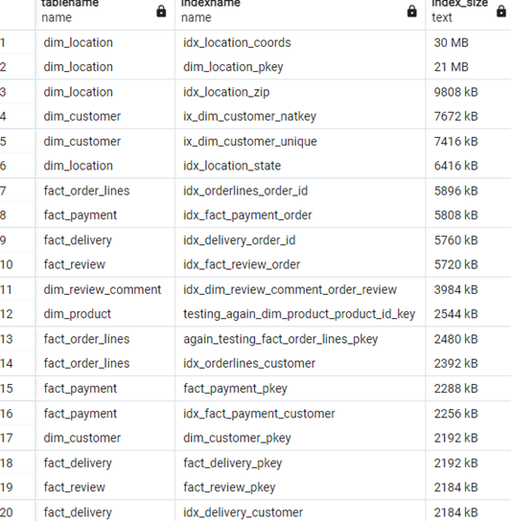

4.3 ETL Performance Optimization (Pentaho)
Table output steps use batch insert mode (use batch=Y), which groups multiple insert statements into single batch operation. This reduces
- Transaction overhead
- Overall load time by 5-10x compared to row-by-row inserts.

Commit size optimization
- 1000 rows are optimal for our dataset size – fast commits without excessive memory usage. 100 is too low (transaction overhead), 100 000 is too large (memory pressure)

Row buffer configuration
Row buffer size: 10000 rows enable efficient streaming between transformation steps.
- Reduces I/O wait time between steps

CSV Input Optimization
CSV buffer size, 50000 bytes optimizes file reading.
- Enables efficient reading of large csv files.

Data Quality Filtering
The filter rows step eliminates invalid data before database insert.
- Invalid rows logged to error files for review
- Reduces ETL rollback and failure
- NOT NULL on critical fields such as Pk’s is important for data integrity

SQL Analytical Queries - Query results and analytical outputs
We have developed a total of 10 analytical SQL queries to demonstrate key dimensional modeling concepts. These queries help us better understand business performance, for example, by analyzing year-over-year revenue growth, customer lifetime value, 7 day moving averages of daily revenue, and other performance KPI calculations. Detailed query results can be found in the database folder. The following are analytical output to each query:
1A. The output shows year over year revenue growth by month. Revenue increased significantly in 2017, with growth of more than 2,000% in September and more than 60,000% in December compared to the same month in the previous year. Growth in 2018 slowed down, eventually reaching negative growth in September 2018.
1B. The output compares each month’s average revenue to the overall average revenue, serving as an indicator of how each month performs relative to the average month. It reveals a seasonal pattern, with November performing significantly better than the rest of the year. In contrast, September, October, January, and February show weaker sales. Businesses can use this insight to optimize marketing timing and inventory planning.
2A. This table shows total revenue by year, month, and product category. It indicates that business revenue increased each year from 2016 to 2018. It also highlights popular categories such as Watches & Gifts, Health & Beauty, Sports & Leisure, and computers & accessories. It is easy to compare sales performance across different months as well.
2B. This is a hierarchical dimension analysis showing product-level revenue with subtotals per category and a grand total. The top three categories generating the highest revenue over the entire period are Health & Beauty, Watches & Gifts, and Bed, Bath & Table. The analysis also makes it possible to see which products generate the most revenue within each category. This provides valuable insights into popular products and can inform product purchasing and inventory decisions.
3A. This query ranks customers by revenue within each state and assigns them to percentile bands (1–100) based on their revenue. It displays each customer’s total revenue along with their rank within the state, making it easy to identify top performing customers in each region.
3B. This query shows the 7 day moving average of daily revenue as well as the year to date cumulative revenue. The days with the highest 7 day moving averages are 11/29/2017, 11/30/2017, 11/28/2017, 11/27/2017, and 11/26/2017, indicating that late November (likely the Black Friday period) represents a peak revenue period. The company can use this insight to plan marketing campaigns, allocate additional staff, and increase inventory accordingly.
4A. This query identifies products that have more than three late deliveries, an average review score below 3, and were sold to customers in the state “SP.” The results are a list of product IDs that highlight products likely to have delivery issues and cause customer dissatisfaction in this specific region. The company can use this information to inspect these products, address the underlying problems, and improve customer satisfaction in “SP”.
4B. This query identifies products with above average prices within their category. The result highlights premium products in each category. It can also help detect mispriced products. The company can use this price information to optimize its pricing structure, adjust discounts, and make more informed pricing strategy decisions.
5A. This query identifies the top 20 customers by lifetime revenue, along with their order behavior and location. The results show that most top customers made only one order, a few made two to three orders, and one customer made four orders. Five of these customers are from the SP region, suggesting an opportunity to target marketing campaigns in SP and to apply different sales strategies, such as retention and upselling, based on the customers’ purchasing behavior.
5B. This query calculates monthly key performance indicators (KPIs) including order volume, average order value, on-time delivery rate, and average review score. The results show that the number of orders grew rapidly in 2017 and stabilized in 2018. Average order value and on-time delivery rates remained relatively stable over time. Review scores were notably lower in November and December 2017, likely due to the higher volume of orders during these peak months. This suggests that the company should optimize its logistics operations during peak seasons to maintain customer satisfaction.

Python Analytics Integration - Business interpretation of findings
We connected a Python script to a PostgreSQL data warehouse hosted on Azure using a dummy account called “test.” To prepare the data for analysis, we structured the dataset at the order_id level, with each row containing relevant information such as order_date, customer_key, quantity, product_value, freight_value, and more. The Python script then generated the data into a file named analysis_data.csv. We conducted descriptive, predictive, and prescriptive analyses, and the business interpretations of the findings are presented as follows:

Descriptive analysis – on time delivery analysis
This refers to “Appendix A”. It shows a descriptive statistic containing mean, standard deviation, minimum, 25th percentile, median, 75th percentile and maximum for "items","product_value","freight_value","order_total_value", "weight_kg","avg_distance_km","paid_total","avg_review_score". These statistics summarize the distribution of our numeric data. The data shows that, in general, orders contain only one item, are lightweight, and cover relatively short distances. However, there are occasional orders with very high values, heavy weights, and long shipping distances, resulting in large standard deviations and high maximum values, particularly for product value and average distance.
The correlation table indicates that the average review score has the highest correlation with delivery delay, suggesting that delays are likely to lead to lower review scores. Improving delivery performance could therefore have a significant positive impact on customer review ratings.

Descriptive analysis – regional sales analysis
This refers to Appendix B, which shows the top 10 states by revenue. SP, RG, and MG are the top three states. This suggests that the company could consider expanding its services in semi-established regions such as RG and MG to further increase revenue.

Predictive analysis – customer churn analysis
This refers to Appendix C. This model predicts whether a customer is going to churn (leave) or stay. Class 1 represents churners, while Class 0 represents non-churners. The model has a precision of 87.1%, meaning that when it predicts churn, it is correct in 87.1% of cases. It also has a recall of 98.3%, which indicates that it successfully identifies almost all churners. The data further shows that average freight is the factor with the highest predictive power for churn.

Predictive analysis - Price Elasticity Analysis
This refers to Appendix D. The data shows that customers are very sensitive to price changes. On average, a 1% price cut results in a 2.8% decrease in demand.

Prescriptive analysis - Freight Cost Optimization
This refers to Appendix E. The model divides distance into five different bands and suggests an 8% decrease in the delivery rate per kilometer for bands that have an on time delivery percentage of 90% or higher. The first four bands show a reduced delivery rate after optimization, while the last band (>1000 km) remains unchanged because its on time delivery percentage is below 90%.

Prescriptive analysis: Customer Segmentation Strategy
This refers to Appendix F. The model divides customers into nine groups using a 3×3 (value × frequency) matrix. It then suggests different actions, such as VIP programs, re-engagement campaigns, upselling, bundling and more, to target each customer segment and increase revenue.

Prescriptive Model: Delivery Performance Optimization
This refers to Appendix G. The data shows that AL, RR, MA, SE, CE, and PI are the top five states with the highest risk of delivery delays. The analysis includes recommended actions, such as upgrading logistics partners, to help reduce these delays.

7. Documentation of DAX calculations and design decisions

7.1 Dax calculations
The total revenue is price + freight_value. Both are ine fact_order_lines


For revenue goal kpi. We have to hit 850 000 total revenue each month.

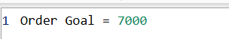
Total orders goal kpi, we have to hit 7000 each month

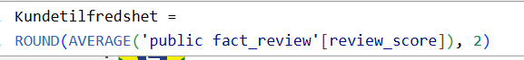
For customer satisfaction kpi, this gives us AVARAGE review score

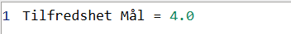
For Customer Satisfaction kpi, we have to hit 4 review score

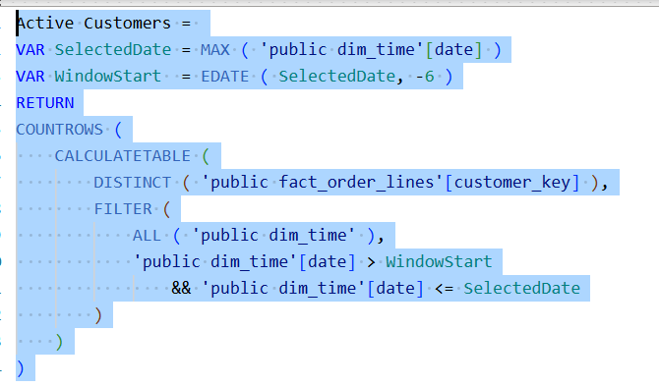
This calculates the number of active customers over past 6 months relative to the currently selected date.
- SelectedDate – Captures the latest date in the current filter conext (date slicer)
- WindowStart – Edate() to move 6 months back from the selected date
- Filter() – Applies a rolling 6-month date window to the entire date table (ALL(‘public dim_time’) removes existing filters
- Distinct(Customer_key) – Ensures each customer is counted only once, even if they have multiple orders
- Countrows – Counts how many distinct customers are active within that 6-month window
1 of my advanced dax calculatins

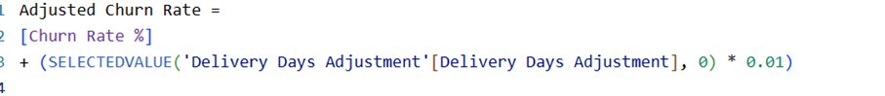
This measure belongs to the what if analysis. It adjusts customer churn rate based on delivery days. If deliery day gets 1 day more, churn rate will increase by 1%.


Churn KPI, we cannot have above 35% churned customers. I have reversed the KPI, so lower is better

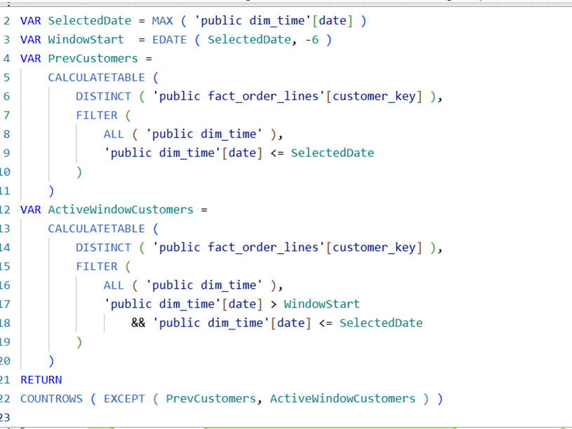
This measure calculates how many customers have churned, meaning customers who made purchases before the current 6-month period within it.
I have used Claude for this advanced dax.
- PrevCustomers – Creates a table of all customers who have ever purchased before the selected date
- Except() – Returns customers present PrevCustoemrs but not in ActiveWindowCustomers (those who stopped buying)
This is my second advanced Dax calculation created by the help of Claude

Percentage of customers who have churned. Formula logic, churned/ churned + active. Relies on heawier dax calculation but is «easy» as itself.

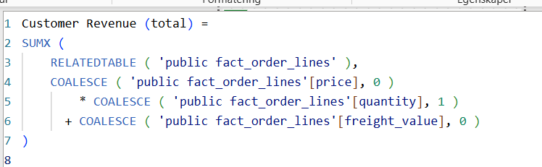

First measure calculates total revenue per customer, like said before. Total revenue is sales and freight income.
The second measure decides if the custoemr is high value or low value. If he/she have bought more than in their total revenue 1000 they become high value.
Sumx() – Iterates over all related order line records for each customer
RELATEDABLE() – Retrieves all orders linked to the current customer context
COALESCE() – Replaces any missing (BLANK) values with default of (0 or 1), preventing calc errors
Calc logic – price * quantity + freight produces the total value of each order line

These advanced dax calculations have i used for analytical deep dive, Claude have been used for troubleshooting to save time.

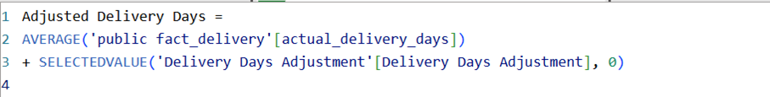

For what if analysis
- Selected Value – reads the user-selected adjustment value from what if slider

What if parameter, you can range delivery day values fra -10 to 10, and it increments by 1

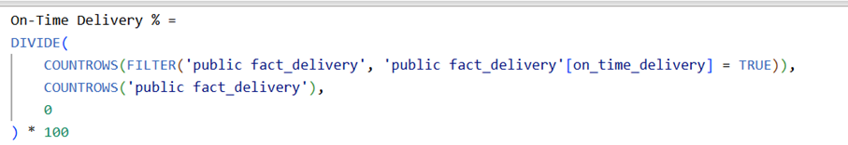

This measure simply calculates the percentage of deliveries completed on or before the promised date.
Filter() – Selects only the rows in the delivery table where on_time_delivery is TRUE
COUNTROWS() – Counts how many deliveries meet the condition
DIVIDE() – Divides the number of on-time deliveries by the total numbers of deliveries
*100 – converts to procentage format

7.2 Design decisions
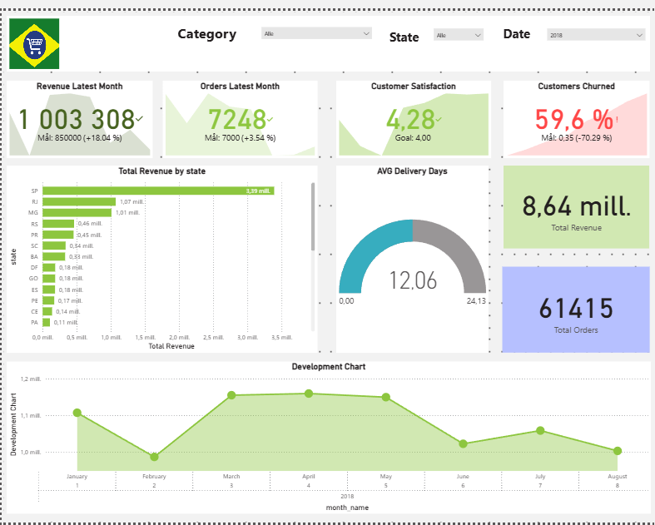

For the summary page, I first tried different colors, but it was for heavy on the eyes. Light colors make it easy to read, therefore easier to understand. I tried to choose colors that were easy and matched with the rest of the visuals. It starts with the header; I have chosen this header on all four pages. It has a picture I found a picture on google that looks like Brazillian E-commerce, the header has three relevant slices with names. Category, State and Date. I chose gardins for the slicers as they are clean and industry standard. For the body, I wanted to have the most relevant KPIs first so they can get attention. I also chose to have with two relevant cards, one for total revenue and one for total orders. These cards sum up whichever slicers we slide between, but the KPIS is just the latest month that is chosen I the slicer. For avg delivery days I have a visual measure, very simple that gives of overview and that is what we are looking for. Finally, we have bigger visualizations for revenue for total states and a development chart. This is also industry standard, we need to see development in a way we get info, and it is easy on the eyes. Thats why i got shadows and dots, as i believe it makes it much easier to look over. Overall, a clean and industry standard dashboard. This sums up overall the other pages as well.

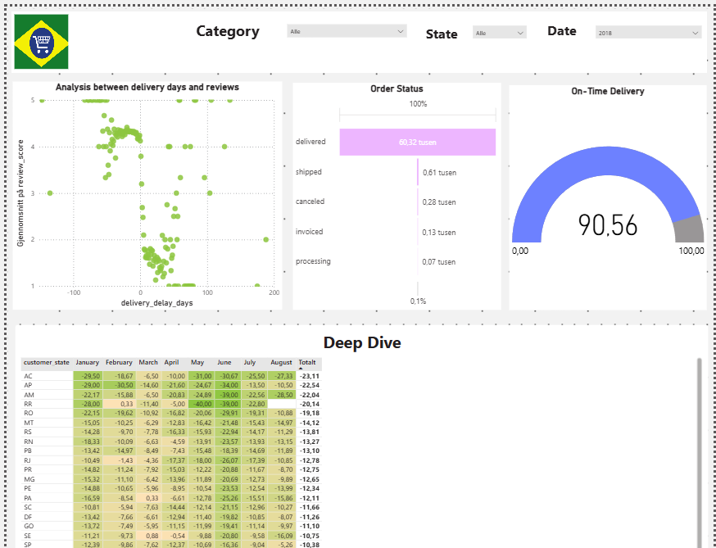
Here we have the operational dashboard. The same header. As we can see, like the dashboard. There is space between the visuals, the sides and even the header. This is to follow industry standards again so the eyes can read intresting facts. This was PointDiagram was perfect for an analysis between delivery days and reviews and a treechart for order status. I had to have a metrics/heat map with since it is the most relevant for the industry. I chose to have differen format for colours, the ones that are very green have delivered before estimation. Then it gets lighter to red, the red ones is when it is late delivery. Using green and red is powerful when it comes to looking the right and the wrong. A measure again, where we can easy see how many deliveries are on time. We can choose the filters for what we want to analyze.

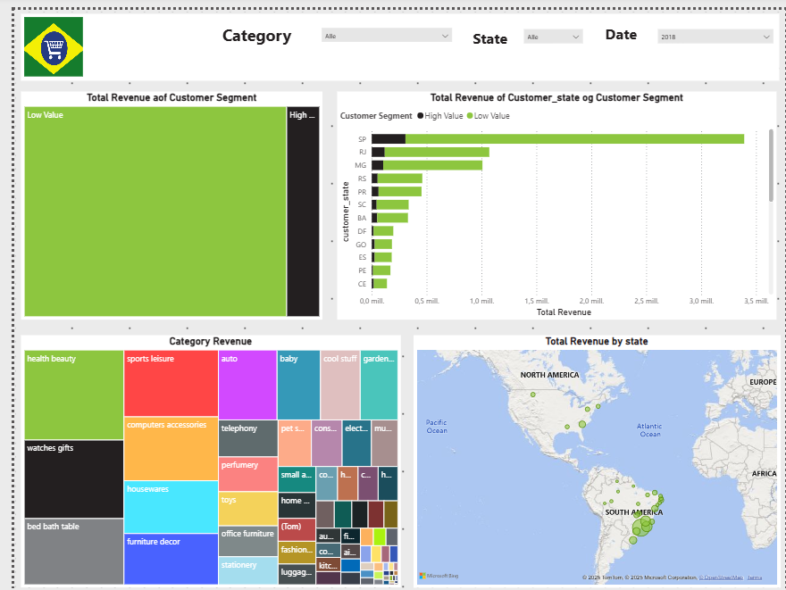
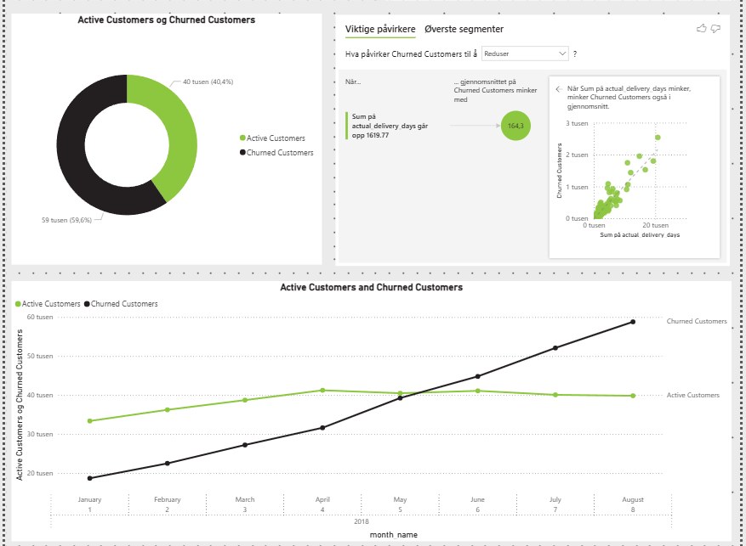
This is the analytical deep dive page. As we can see, it uses much more space and is bigger than the dashboards. Again, the same header. We start with seeing Total revenue for customers and they are either high or low customers, and under we have a treemap that shows us the most relevant categories. And to the right we have a map. This gives us an overview and deep dive of our customers, how much they shop, what they shop for and if they pay high prices and low prices.
The second part we have active and churned customers. Even an AI visual that helps us with the analysis. It clearly says that delivery days and churned customers are linked. The fewer the days, the fewer customers churned. And at the bottom a line graph for churned and active customers. I tried to make this page as basic as possible, as it has some advanced calculations. I have not changed the colours, basic white. Black and green for comparing high and low customers, black and green for churned and active customers. It just makes sense, so why change it? The page is easy to read and understand and gives us an analytical deep dive for customers and sales.

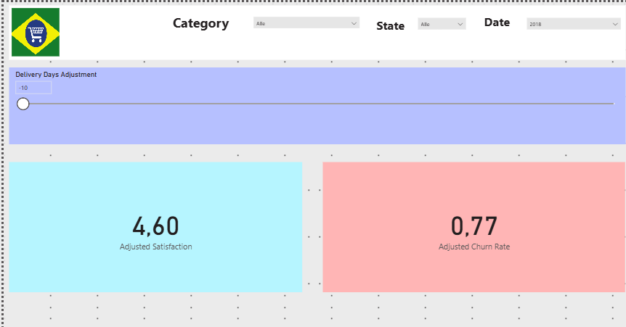

This is the what if analysis page, it felt to empty. So, I decided to give it light colors so it does not get too boring. The header as before is like the rest to keep integrity. And nice light colors so it grabs attention.

Reference
Sharda, R., Delen, D., & Turban, E. (2024). Business intelligence, analytics, data science, and AI: A managerial perspective. Pearson.
Kimball, R., & Ross, M. (2013). The Data Warehouse Toolkit: The Complete Guide to Dimensional Modeling (3rd ed.). John Wiley & Sons, Incorporated.

APPENDIX

APPENDIX A
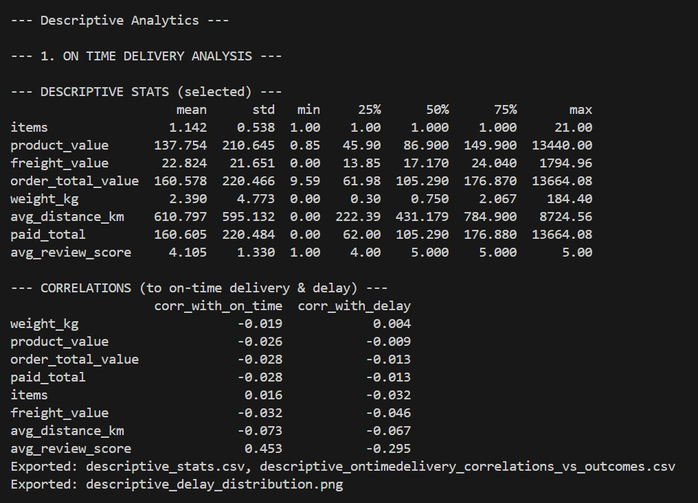

APPENDIX B
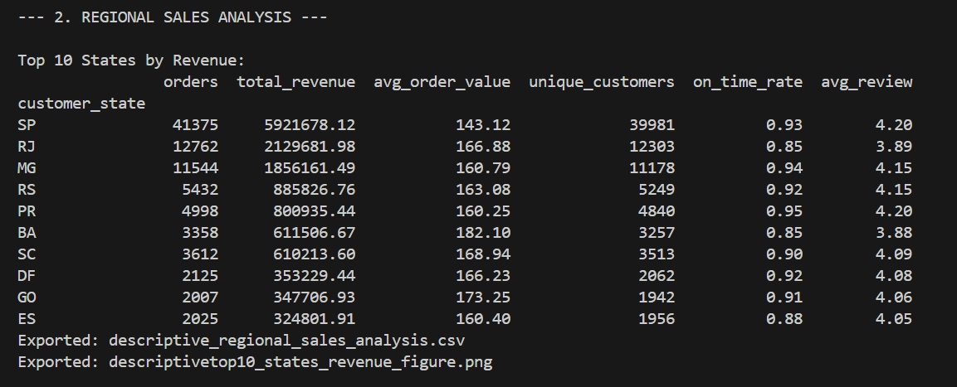

APPENDIX C
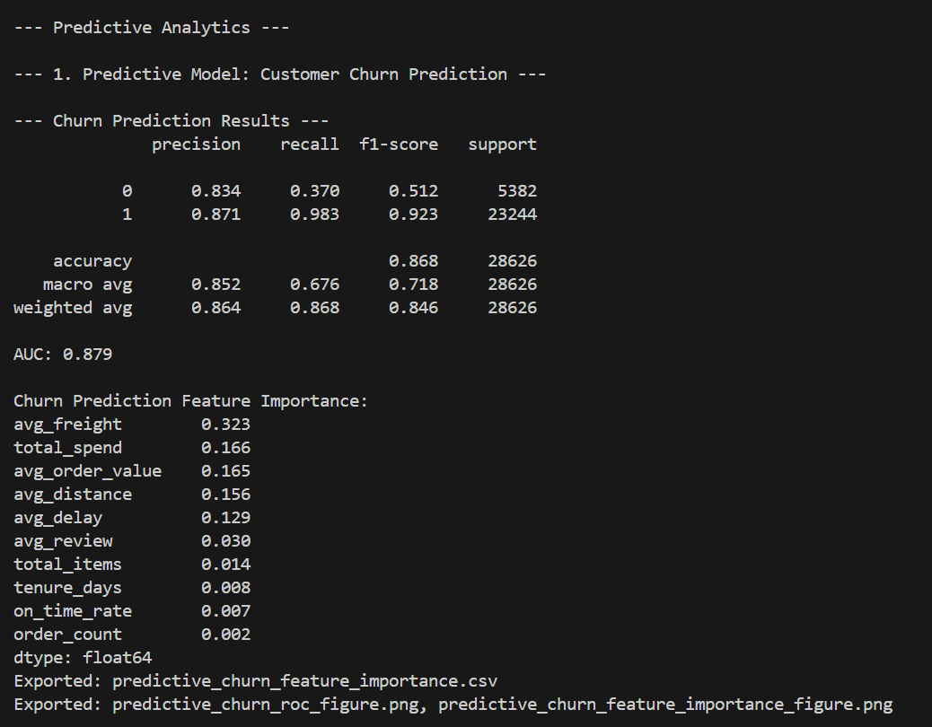

APPENDIX D
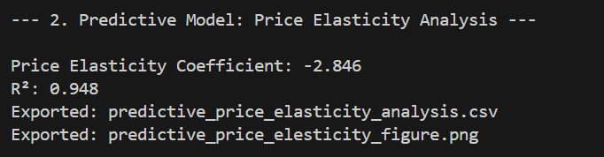

APPENDIX E
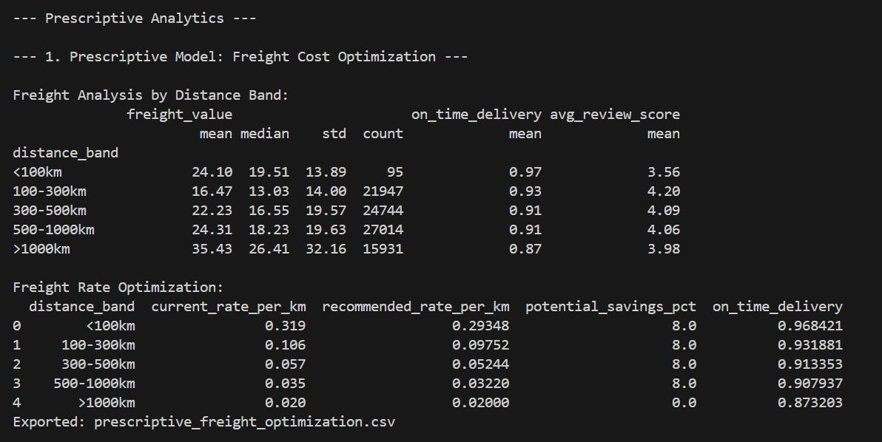

APPENDIX F
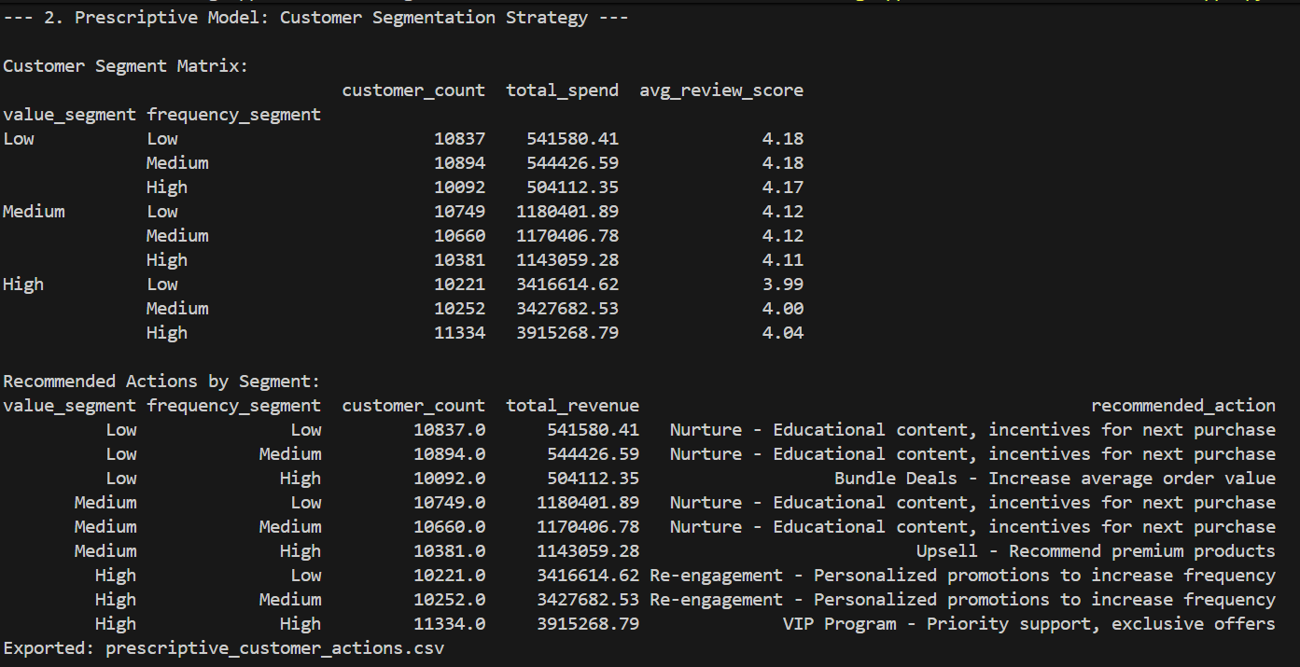

APPENDIX G
